**IDIVE TRIPS (Front)**

**BROWSER- Mozilla Firefox**

**DATE- 17/02/2014**

|  |  |  |  |  |  |  |  |  |  |
| --- | --- | --- | --- | --- | --- | --- | --- | --- | --- |
| **Test Case ID** | **Module** | **Features** | **Objectives** | **Step/User Action** | **Expected Result** | **Actual Result** | **Status** | **Developer Comment** | **Tester Comment** |
| TC 01 | Homepage | Functionality | To validate the functionality of **Company Logo** | 1. Enter the URL **http://192.168.0.26/idive**  2. Click on the **Company Logo** mentioned on the top of the page | 1. User should be redirected to the Homepage  2. User should be redirected to the Homepage | 1. User is redirected to the Homepage  2. “Company Logo” link is not working | **Done** |  |  |

**Snapshot Attached-**

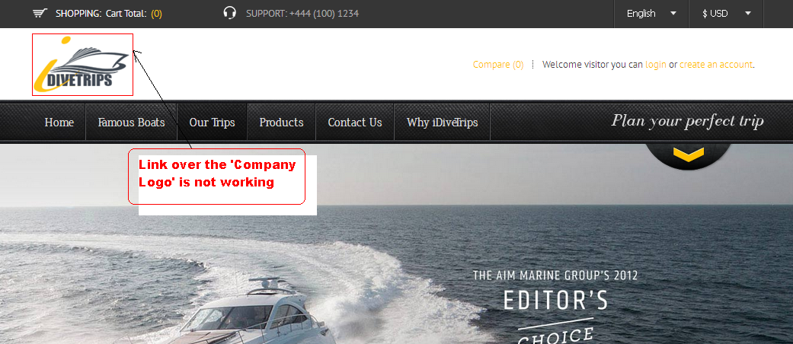

|  |  |  |  |  |  |  |  |  |  |
| --- | --- | --- | --- | --- | --- | --- | --- | --- | --- |
| **Test Case ID** | **Module** | **Features** | **Objectives** | **Step/User Action** | **Expected Result** | **Actual Result** | **Status** | **Developer Comment** | **Tester Comment** |
| TC 02 | Homepage | Functionality | To validate the functionality of main menus | 1. Enter the URL **http://192.168.0.26/idive**  2. Click on the **“Famous Boat’s & Product’s** sub menus | 1. User should be redirected to the Homepage  2. User should be redirected to the respective pages | 1. User is redirected to the Homepage  2. Sub Menus are not working | **Done** |  |  |

**Snapshot Attached-**

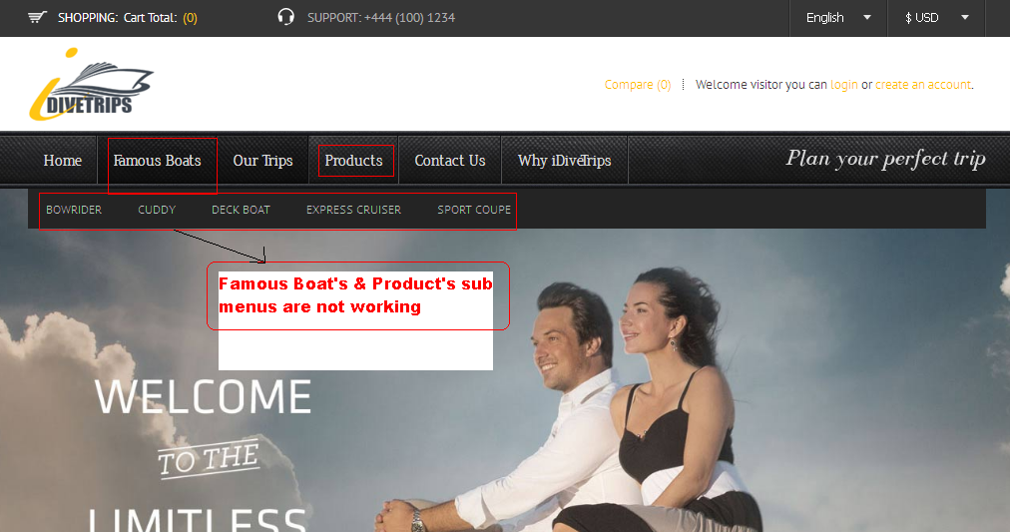

|  |  |  |  |  |  |  |  |  |  |
| --- | --- | --- | --- | --- | --- | --- | --- | --- | --- |
| **Test Case ID** | **Module** | **Features** | **Objectives** | **Step/User Action** | **Expected Result** | **Actual Result** | **Status** | **Developer Comment** | **Tester Comment** |
| TC 03 | Login | Functionality | To validate the functionality of **Forgot Password** link | 1. Enter the URL **http://192.168.0.26/idive**  2. Click on the **Login** link mentioned on the top right side of the page  3. Now click on the **Forgot Password** link | 1. User should be redirected to the Homepage  2. Login page should be appear  3**. Forgot Password** page should be appear | 1. User is redirected to the Homepage  2. Login page is appearing  3. Link on the **Forgot Password** is not working | **Done** |  |  |

**Snapshot Attached-**

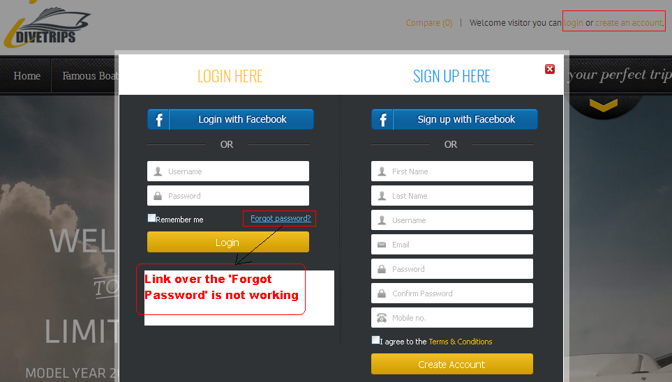

|  |  |  |  |  |  |  |  |  |  |
| --- | --- | --- | --- | --- | --- | --- | --- | --- | --- |
| **Test Case ID** | **Module** | **Features** | **Objectives** | **Step/User Action** | **Expected Result** | **Actual Result** | **Status** | **Developer Comment** | **Tester Comment** |
| TC 04 | Login | Functionality | To verify that the Mobile No. field is not accepting the infinite length of characters | 1. Enter the URL **http://192.168.0.26/idive**  2. Click on the **Create an Account** link mentioned on the top right side of the page  3. Enter the infinite characters in the **Mobile No.** field and click on the **Create an Account** button | 1. User should be redirected to the Homepage  2. **Sign Up** page should be appear  3**. Mobile No.** field should not accept more than 15numeric characters | 1. User is redirected to the Homepage  2. **Sign Up**  pageis appearing  3. **Mobile No.** field is accepting infinite length of characters | **Done** |  |  |

**Snapshot Attached-**

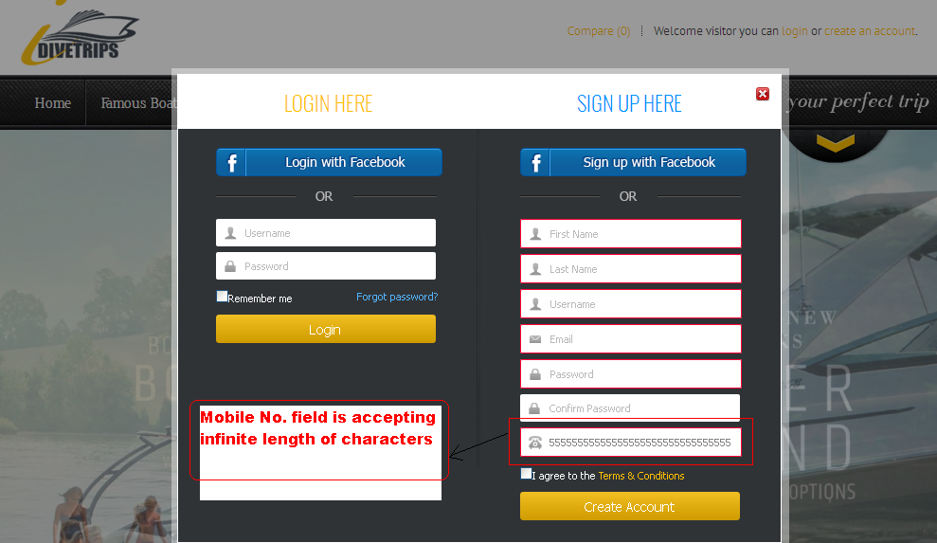

|  |  |  |  |  |  |  |  |  |  |
| --- | --- | --- | --- | --- | --- | --- | --- | --- | --- |
| **Test Case ID** | **Module** | **Features** | **Objectives** | **Step/User Action** | **Expected Result** | **Actual Result** | **Status** | **Developer Comment** | **Tester Comment** |
| TC 05 | Login | Functionality | To verify that the Password fields are not accepting the infinite length of characters | 1. Enter the URL **http://192.168.0.26/idive**  2. Click on the **Create an Account** link mentioned on the top right side of the page  3. Enter the infinite characters or only one or two characters in the **Password** fields and click on the **Create an Account** button | 1. User should be redirected to the Homepage  2.  **Sign Up** page should be appear  3**.** Validation message (Must be 4 to 20 characters) should appear | 1. User is redirected to the Homepage  2. **Sign Up**  pageis appearing  3. Validation message is not prompting | **Done** |  |  |

**Snapshot Attached-**

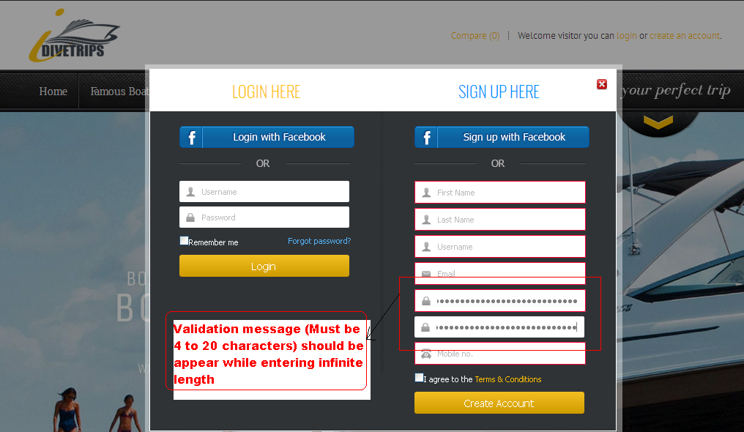

|  |  |  |  |  |  |  |  |  |  |
| --- | --- | --- | --- | --- | --- | --- | --- | --- | --- |
| **Test Case ID** | **Module** | **Features** | **Objectives** | **Step/User Action** | **Expected Result** | **Actual Result** | **Status** | **Developer Comment** | **Tester Comment** |
| TC 06 | Login | Functionality | To verify that the Refresh page is open each time for a “Sign Up” page | 1. Enter the URL **http://192.168.0.26/idive**  2. Click on the **Create an Account** link mentioned on the top right side of the page  3. Enter the invalid characters or in the fields and click on the **Create an Account** button  4. Now close the Sign up pop up window  5. Again open the Sign up pop up window | 1. User should be redirected to the Homepage  2.  **Sign Up** page should be appear  3**.** Validation message should appear  4. Sign up pop up window should be closed  5. Refresh pop up window should be appear | 1. User is redirected to the Homepage  2. **Sign Up**  pageis appearing  3. Validation message is appearing  4. Sign up pop up gets closed  5. Refresh Sign up pop up window is not appearing | **Done** |  |  |

**Snapshot Attached-**

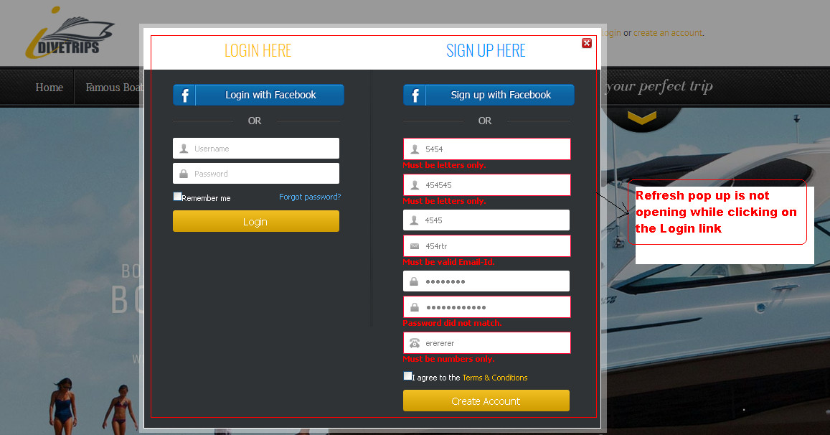

|  |  |  |  |  |  |  |  |  |  |
| --- | --- | --- | --- | --- | --- | --- | --- | --- | --- |
| **Test Case ID** | **Module** | **Features** | **Objectives** | **Step/User Action** | **Expected Result** | **Actual Result** | **Status** | **Developer Comment** | **Tester Comment** |
| TC 07 | Login | Functionality | To validate the functionality of “Terms & Conditions” link | 1. Enter the URL **http://192.168.0.26/idive**  2. Click on the **Create an Account** link mentioned on the top right side of the page  3. Click on the **Terms & Conditions** link mentioned under the last field | 1. User should be redirected to the Homepage  2. **Sign Up** page should be appear  3**.** User should be redirected to the **“Terms & Conditions”** page | 1. User is redirected to the Homepage  2. **Sign Up** pageis appearing  3. **“Terms & Conditions”** link is not working | Done |  |  |

**Snapshot Attached-**

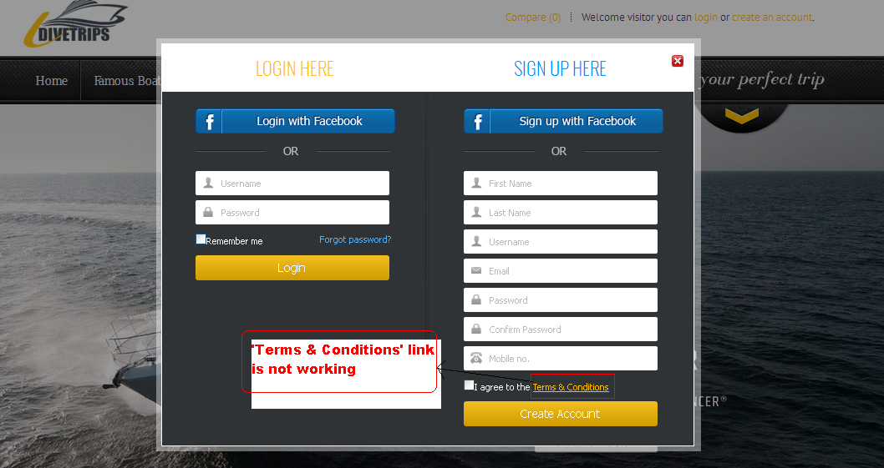

|  |  |  |  |  |  |  |  |  |  |
| --- | --- | --- | --- | --- | --- | --- | --- | --- | --- |
| **Test Case ID** | **Module** | **Features** | **Objectives** | **Step/User Action** | **Expected Result** | **Actual Result** | **Status** | **Developer Comment** | **Tester Comment** |
| TC 08 | Homepage | Functionality | To validate the functionality of link mention on the footer | 1. Enter the URL **http://192.168.0.26/idive**  2. Click on the links mentioned on the footer | 1. User should be redirected to the Homepage  2. User should be redirected to the respective pages of the link | 1. User is redirected to the Homepage  2. Links mentioned on the footer are not working | **Done** |  |  |

**Snapshot Attached-**

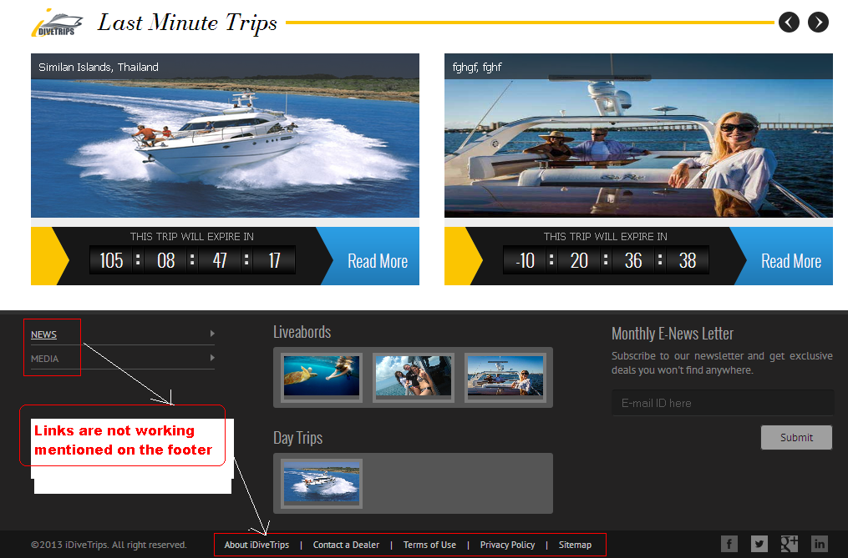

|  |  |  |  |  |  |  |  |  |  |
| --- | --- | --- | --- | --- | --- | --- | --- | --- | --- |
| **Test Case ID** | **Module** | **Features** | **Objectives** | **Step/User Action** | **Expected Result** | **Actual Result** | **Status** | **Developer Comment** | **Tester Comment** |
| TC 09 | Our Trips | Functionality | To validate the functionality of Breadcrumbs | 1. Enter the URL **http://192.168.0.26/idive**  2. Click on the Header menu **“Our Trips”**  3. Click on the **View Detail** button mentioned for the respective Trips  4. Click on the **Breadcrumbs** mentioned on the page | 1. User should be redirected to the Homepage  2. User should be redirected to the **“Our Trips”** page  3. View Detail page should be opened  4. User should be redirected to the respective Breadcrumbs | 1. User is redirected to the Homepage  2. User is redirected to the **“Our Trips”** page  3. View Detail page is opened  4. Breadcrumbs are not working correctly | **Done** |  |  |

**Snapshot Attached-**

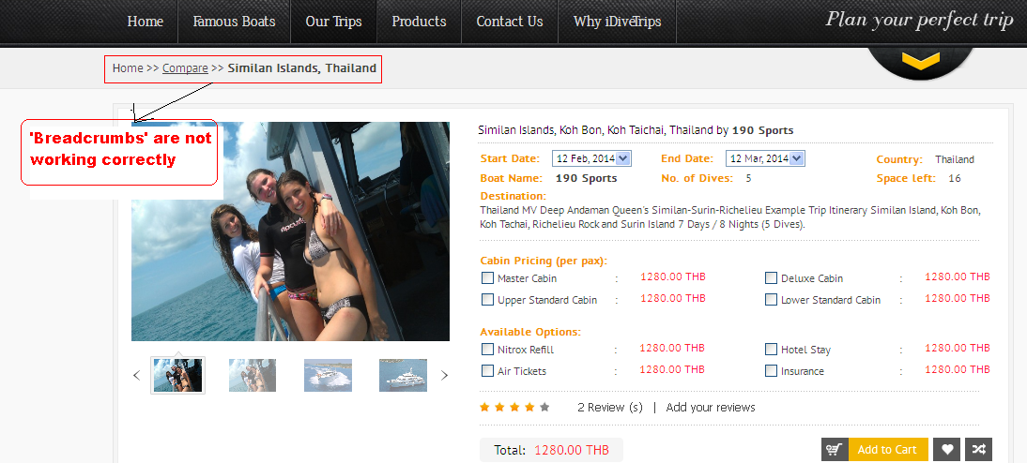

|  |  |  |  |  |  |  |  |  |  |
| --- | --- | --- | --- | --- | --- | --- | --- | --- | --- |
| **Test Case ID** | **Module** | **Features** | **Objectives** | **Step/User Action** | **Expected Result** | **Actual Result** | **Status** | **Developer Comment** | **Tester Comment** |
| TC 10 | Our Trips | GUI | To verify that Breadcrumbs are mentioned correctly | 1. Enter the URL **http://192.168.0.26/idive**  2. Click on the Header menu **“Our Trips”**  3. Click on the **View Detail** button mentioned for the respective Trips  4. Observe that the Breadcrumbs are mentioned properly | 1. User should be redirected to the Homepage  2. User should be redirected to the **“Our Trips”** page  3. View Detail page should be opened  4. Breadcrumbs should be mentioned correctly | 1. User is redirected to the Homepage  2. User is redirected to the **“Our Trips”** page  3. View Detail page is opened  4. 2nd level Breadcrumb is not mentioned correctly | **Done** |  |  |

**Snapshot Attached-**

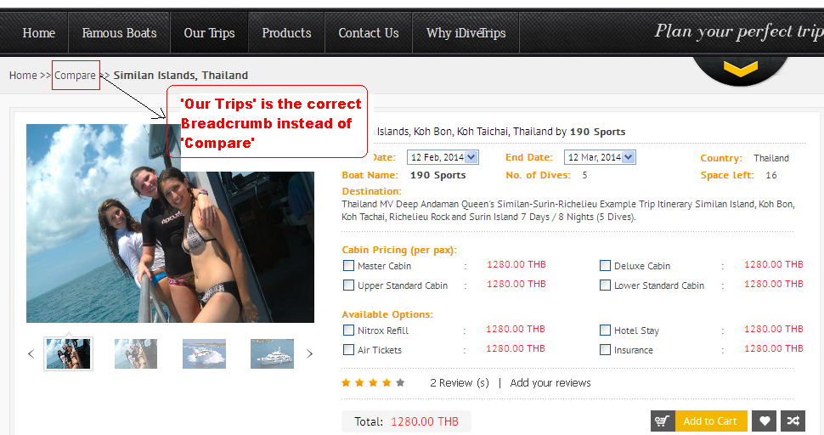

|  |  |  |  |  |  |  |  |  |  |
| --- | --- | --- | --- | --- | --- | --- | --- | --- | --- |
| **Test Case ID** | **Module** | **Features** | **Objectives** | **Step/User Action** | **Expected Result** | **Actual Result** | **Status** | **Developer Comment** | **Tester Comment** |
| TC 11 | Our Trips | Functionality | To validate the functionality of Breadcrumbs | 1. Enter the URL **http://192.168.0.26/idive**  2. Click on the Header menu **“Our Trips”**  3. Click on the **View Boat Specification** mentioned for the respective Trips  4. Click on the **Breadcrumbs** mentioned on the page | 1. User should be redirected to the Homepage  2. User should be redirected to the **“Our Trips”** page  3. **Boat Specification** page should be opened  4. User should be redirected to the respective Breadcrumbs | 1. User is redirected to the Homepage  2. User is redirected to the **“Our Trips”** page  3.  **Boat Specification** page is opened  4. Breadcrumbs are not working correctly | **Done** |  |  |

**Snapshot Attached-**

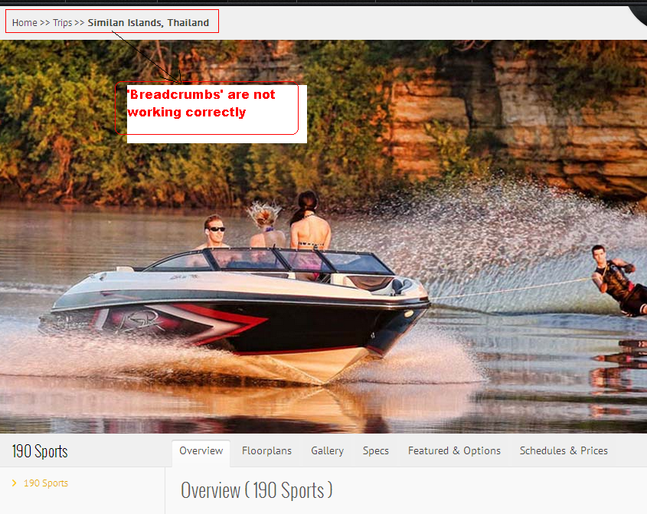

|  |  |  |  |  |  |  |  |  |  |
| --- | --- | --- | --- | --- | --- | --- | --- | --- | --- |
| **Test Case ID** | **Module** | **Features** | **Objectives** | **Step/User Action** | **Expected Result** | **Actual Result** | **Status** | **Developer Comment** | **Tester Comment** |
| TC 12 | Our Trips | Functionality | To validate the functionality of **Add Your Reviews** link | 1. Enter the URL **http://192.168.0.26/idive**  2. Click on the Header menu **“Our Trips”**  3. Click on the **View Detail** button mentioned for the respective Trips  4. Click on the **Add Your Reviews** link | 1. User should be redirected to the Homepage  2. User should be redirected to the **“Our Trips”** page  3. View Detail page should be opened  4. Review page should be opened for adding the Review | 1. User is redirected to the Homepage  2. User is redirected to the **“Our Trips”** page  3. View Detail page is opened  4. **Add You Review** link is not working | Done |  |  |

**Snapshot Attached-**

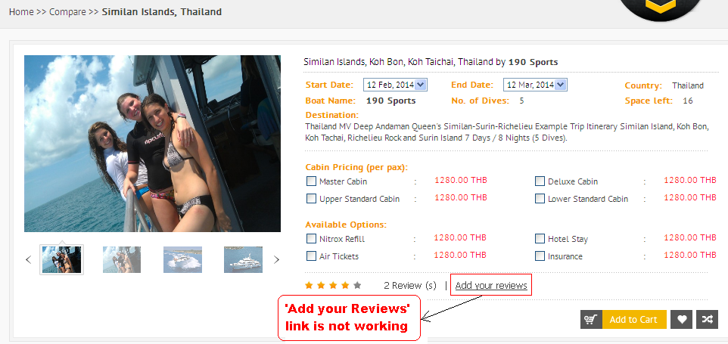

|  |  |  |  |  |  |  |  |  |  |
| --- | --- | --- | --- | --- | --- | --- | --- | --- | --- |
| **Test Case ID** | **Module** | **Features** | **Objectives** | **Step/User Action** | **Expected Result** | **Actual Result** | **Status** | **Developer Comment** | **Tester Comment** |
| TC 13 | My Account | Functionality | To verify that the  **First Name, Last Name** & **Mobile** fields are not accepting the invalid characters | 1. Enter the URL  **http://192.168.0.26/idive**  2. Click on the **Login** link mentioned on the top right side of the page  3. Enter the valid **Email id** and **Password** and click on the **Login** button  4. Now click on the **My Account** link  5. Click on the **Edit Account** Link  6. Enter invalid characters in the **First Name, Last Name** & **Mobile** fields and click on the **Update** button | 1. User should be redirected to the Homepage  2. Login page should be appear  3. **Successful Login** message should appear  4. User should be redirected to the  **My Account** page  5. User should be redirected to the  **Personal Detail** page  6. Validation message should be appear for the mentioned fields | 1. User is redirected to the Homepage  2. Login Page is appearing  3.  **Successful Login** message is appearing  4. User is redirected to the  **My Account** page  5. User is redirected to the **Personal Detail** page  6. Validation message is not appearing for the mentioned fields | **Done** |  |  |

**Snapshot Attached-**

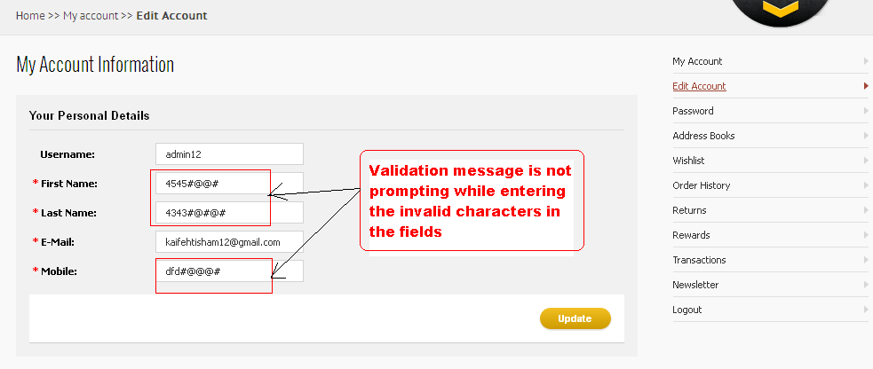

|  |  |  |  |  |  |  |  |  |  |
| --- | --- | --- | --- | --- | --- | --- | --- | --- | --- |
| **Test Case ID** | **Module** | **Features** | **Objectives** | **Step/User Action** | **Expected Result** | **Actual Result** | **Status** | **Developer Comment** | **Tester Comment** |
| TC 14 | My Account | Functionality | To validate the functionality of Breadcrumbs | 1. Enter the URL  **http://192.168.0.26/idive**  2. Click on the **Login** link mentioned on the top right side of the page  3. Enter the valid **Email id** and **Password** and click on the **Login** button  4. Now click on the **My Account** link  5. Click on the **Edit Account** Link  6. Click on the 2nd level **Breadcrumbs (My Account)** | 1. User should be redirected to the Homepage  2. Login page should be appear  3. **Successful Login** message should appear  4. User should be redirected to the  **My Account** page  5. User should be redirected to the  **Personal Detail** page  6. User should be redirected to the **My Account** Page | 1. User is redirected to the Homepage  2. Login Page is appearing  3.  **Successful Login** message is appearing  4. User is redirected to the  **My Account** page  5. User is redirected to the **Personal Detail** page  6. 2nd level Breadcrumb is not working correctly | **Done** |  |  |

**Snapshot Attached-**

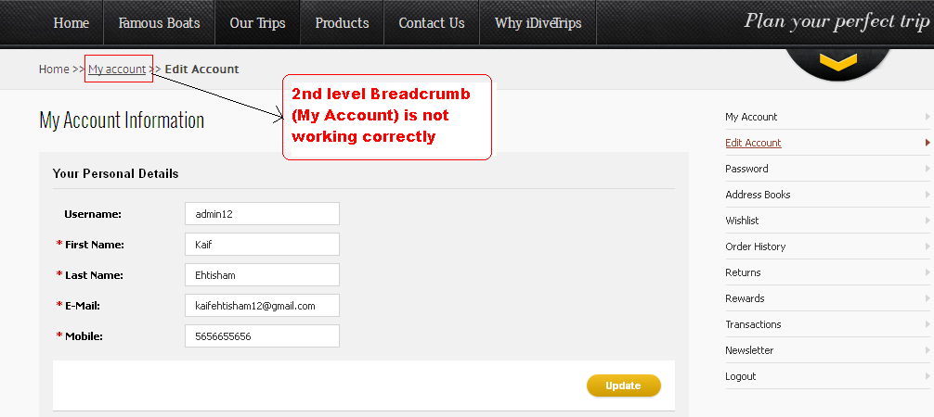

|  |  |  |  |  |  |  |  |  |  |
| --- | --- | --- | --- | --- | --- | --- | --- | --- | --- |
| **Test Case ID** | **Module** | **Features** | **Objectives** | **Step/User Action** | **Expected Result** | **Actual Result** | **Status** | **Developer Comment** | **Tester Comment** |
| TC 15 | My Account | GUI | To verify that the Static text is mentioned correctly | 1. Enter the URL  **http://192.168.0.26/idive**  2. Click on the **Login** link mentioned on the top right side of the page  3. Enter the valid **Email id** and **Password** and click on the **Login** button  4. Now click on the **My Account** link  5. Click on the **Address Books** Link  6. Observe the Static texts mentioned on the page | 1. User should be redirected to the Homepage  2. Login page should be appear  3. **Successful Login** message should appear  4. User should be redirected to the  **My Account** page  5. User should be redirected to the  **Address Book** page  6. Static texts should be mentioned correctly | 1. User is redirected to the Homepage  2. Login Page is appearing  3.  **Successful Login** message is appearing  4. User is redirected to the  **My Account** page  5. User is redirected to the **Address Book** page  6. **Heading** and 4th level **Breadcrumb** is not mentioned correctly | **Done** |  |  |

**Snapshot Attached-**

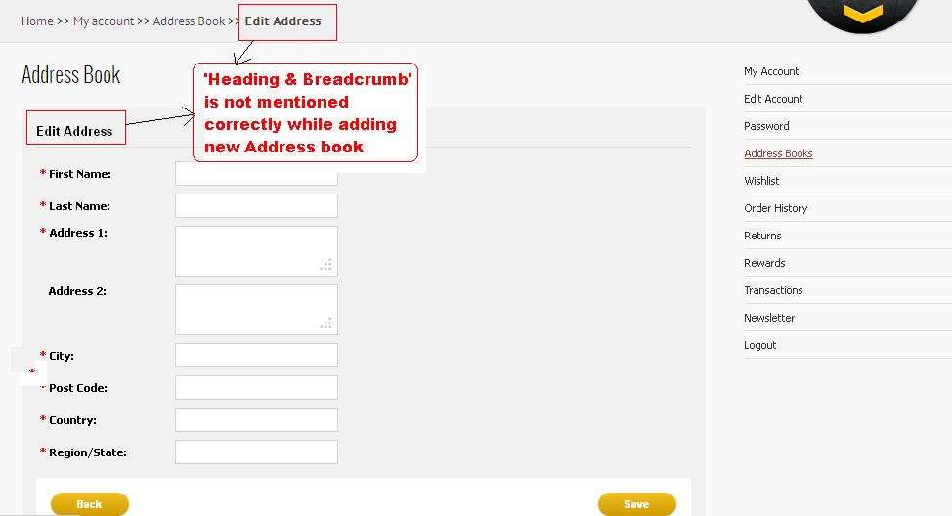

|  |  |  |  |  |  |  |  |  |  |
| --- | --- | --- | --- | --- | --- | --- | --- | --- | --- |
| **Test Case ID** | **Module** | **Features** | **Objectives** | **Step/User Action** | **Expected Result** | **Actual Result** | **Status** | **Developer Comment** | **Tester Comment** |
| TC 16 | My Account | Functionality | To verify that the validation message is appearing for all the mandatory fields | 1. Enter the URL  **http://192.168.0.26/idive**  2. Click on the **Login** link mentioned on the top right side of the page  3. Enter the valid **Email id** and **Password** and click on the **Login** button  4. Now click on the **My Account** link  5. Click on the **Address Books** Link  6. Leave all the mandatory fields blank and click on the **Save** button | 1. User should be redirected to the Homepage  2. Login page should be appear  3. **Successful Login** message should appear  4. User should be redirected to the  **My Account** page  5. User should be redirected to the  **Address Book** page  6. Validation message (Required Field) should be prompt | 1. User is redirected to the Homepage  2. Login Page is appearing  3.  **Successful Login** message is appearing  4. User is redirected to the  **My Account** page  5. User is redirected to the **Address Book** page  6. Validation message is not prompting for **Address 1** and **Country** fields while leaving them blank | **Done** |  |  |

**Snapshot Attached-**

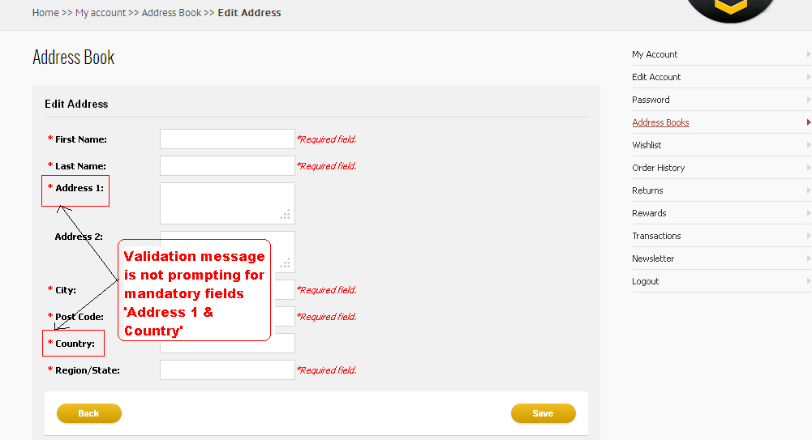

|  |  |  |  |  |  |  |  |  |  |
| --- | --- | --- | --- | --- | --- | --- | --- | --- | --- |
| **Test Case ID** | **Module** | **Features** | **Objectives** | **Step/User Action** | **Expected Result** | **Actual Result** | **Status** | **Developer Comment** | **Tester Comment** |
| TC 17 | My Account | Functionality | To validate the functionality of **Add To Cart** icon | 1. Enter the URL  **http://192.168.0.26/idive**  2. Click on the **Login** link mentioned on the top right side of the page  3. Enter the valid **Email id** and **Password** and click on the **Login** button  4. Now click on the **My Account** link  5. Click on the **Wishlist** Link  6. Click on the **Add To Cart** icon mentioned under table heading **Action** in the grid | 1. User should be redirected to the Homepage  2. Login page should be appear  3. **Successful Login** message should appear  4. User should be redirected to the  **My Account** page  5. User should be redirected to the  **Wishlist** page  6. Trip should be added to the Cart | 1. User is redirected to the Homepage  2. Login Page is appearing  3.  **Successful Login** message is appearing  4. User is redirected to the  **My Account** page  5. User is redirected to the  **Wishlist** page  6. **Add To Cart** icon is not working | Done |  |  |

**Snapshot Attached-**

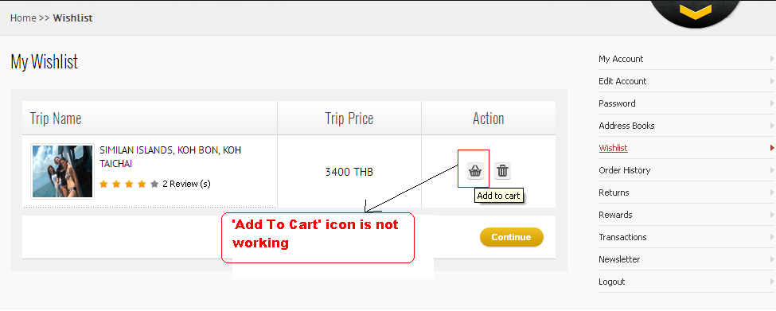

|  |  |  |  |  |  |  |  |  |  |
| --- | --- | --- | --- | --- | --- | --- | --- | --- | --- |
| **Test Case ID** | **Module** | **Features** | **Objectives** | **Step/User Action** | **Expected Result** | **Actual Result** | **Status** | **Developer Comment** | **Tester Comment** |
| TC 18 | My Account | Functionality | To validate the functionality of all the Links mentioned on the page | 1. Enter the URL  **http://192.168.0.26/idive**  2. Click on the **Login** link mentioned on the top right side of the page  3. Enter the valid **Email id** and **Password** and click on the **Login** button  4. Now click on the **My Account** link  5. Click on all the links mentioned on the page | 1. User should be redirected to the Homepage  2. Login page should be appear  3. **Successful Login** message should appear  4. User should be redirected to the  **My Account** page  5. User should be redirected to the respective pages | 1. User is redirected to the Homepage  2. Login Page is appearing  3.  **Successful Login** message is appearing  4. User is redirected to the  **My Account** page  5. **“Order History, Returns, Rewards, Transactions, Newsletters”** links are not working | Done except transaction and newsletter |  |  |

**Snapshot Attached-**

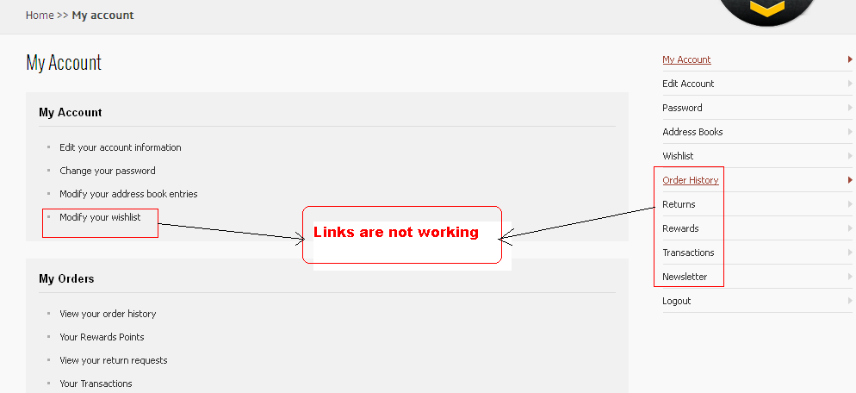

|  |  |  |  |  |  |  |  |  |  |
| --- | --- | --- | --- | --- | --- | --- | --- | --- | --- |
| **Test Case ID** | **Module** | **Features** | **Objectives** | **Step/User Action** | **Expected Result** | **Actual Result** | **Status** | **Developer Comment** | **Tester Comment** |
| TC 19 | My Account | Functionality | To validate the functionality of **Checkout** button | 1. Enter the URL  **http://192.168.0.26/idive**  2. Click on the **Login** link mentioned on the top right side of the page  3. Enter the valid **Email id** and **Password** and click on the **Login** button  4. Place the mouse over the **Shopping Cart**  5. Now Click on the **Checkout** button | 1. User should be redirected to the Homepage  2. Login page should be appear  3. **Successful Login** message should appear  4. **Shopping Cart** pop up should slide down  5. User should be redirected to the **Checkout** page | 1. User is redirected to the Homepage  2. Login Page is appearing  3.  **Successful Login** message is appearing  4. **Shopping Cart** pop up is slide down  5. **Checkout** button is not working | DONE |  |  |

**Snapshot Attached-**

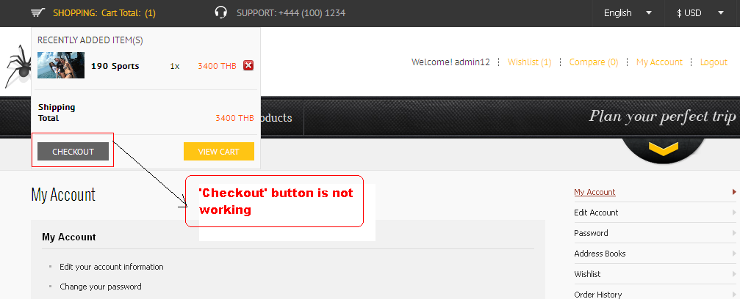

|  |  |  |  |  |  |  |  |  |  |
| --- | --- | --- | --- | --- | --- | --- | --- | --- | --- |
| **Test Case ID** | **Module** | **Features** | **Objectives** | **Step/User Action** | **Expected Result** | **Actual Result** | **Status** | **Developer Comment** | **Tester Comment** |
| TC 20 | My Account | Functionality | To validate the functionality of **Update Your Cart** icon | 1. Enter the URL  **http://192.168.0.26/idive**  2. Click on the **Login** link mentioned on the top right side of the page  3. Enter the valid **Email id** and **Password** and click on the **Login** button  4. Place the mouse over the **Shopping Cart**  5. Now Click on the **View Cart** button  6. Increase the no. of Children in the grid and click on the **Update your Cart** icon | 1. User should be redirected to the Homepage  2. Login page should be appear  3. **Successful Login** message should appear  4. **Shopping Cart** pop up should slide down  5. User should be redirected to the **View Cart** page  6. Total amount should be updated according to that | 1. User is redirected to the Homepage  2. Login Page is appearing  3.  **Successful Login** message is appearing  4. **Shopping Cart** pop up is slide down  5. **View Cart** page is appearing  6. **Update Your Cart** icon is not working properly | DONE |  |  |

**Snapshot Attached-**

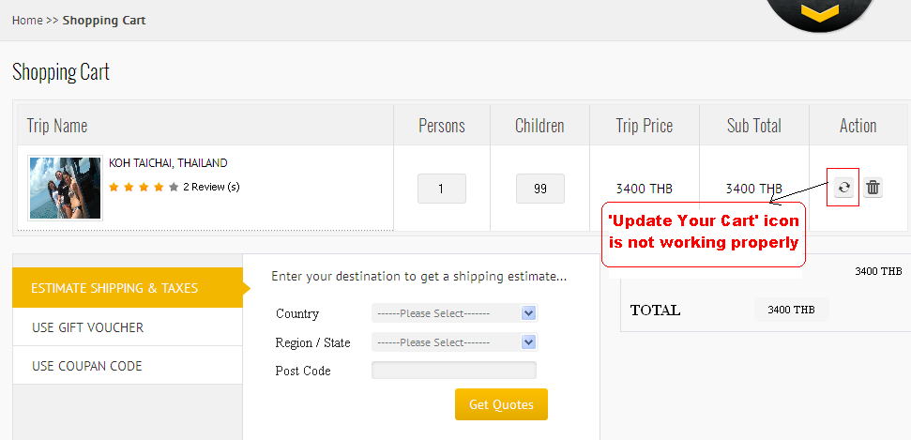

|  |  |  |  |  |  |  |  |  |  |
| --- | --- | --- | --- | --- | --- | --- | --- | --- | --- |
| **Test Case ID** | **Module** | **Features** | **Objectives** | **Step/User Action** | **Expected Result** | **Actual Result** | **Status** | **Developer Comment** | **Tester Comment** |
| TC 21 | My Account | Functionality | To validate the functionality of **Get Quotes** button | 1. Enter the URL  **http://192.168.0.26/idive**  2. Click on the **Login** link mentioned on the top right side of the page  3. Enter the valid **Email id** and **Password** and click on the **Login** button  4. Place the mouse over the **Shopping Cart**  5. Now Click on the **View Cart** button  6. Click on the **Get Quotes** button to get the Shipping Estimate | 1. User should be redirected to the Homepage  2. Login page should be appear  3. **Successful Login** message should appear  4. **Shopping Cart** pop up should slide down  5. User should be redirected to the **View Cart** page  6. User should get the Shipping estimate | 1. User is redirected to the Homepage  2. Login Page is appearing  3.  **Successful Login** message is appearing  4. **Shopping Cart** pop up is slide down  5. **View Cart** page is appearing  6. **Get Quotes** button is not working | Done |  |  |

**Snapshot Attached-**

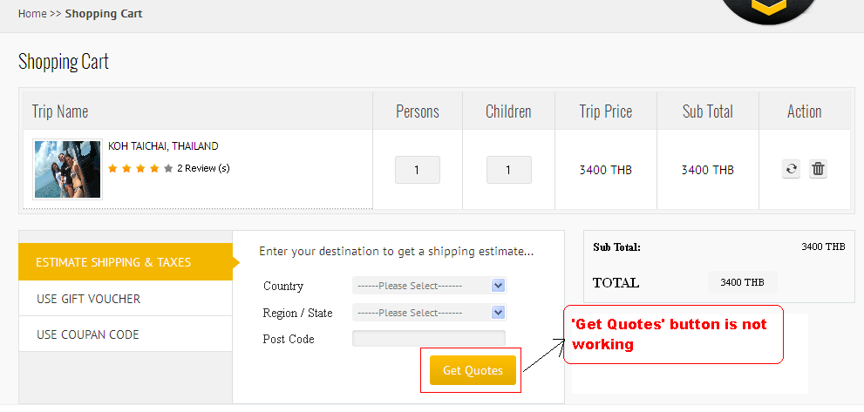

|  |  |  |  |  |  |  |  |  |  |
| --- | --- | --- | --- | --- | --- | --- | --- | --- | --- |
| **Test Case ID** | **Module** | **Features** | **Objectives** | **Step/User Action** | **Expected Result** | **Actual Result** | **Status** | **Developer Comment** | **Tester Comment** |
| TC 22 | My Account | Functionality | To validate the functionality of **Breadcrumbs** | 1. Enter the URL  **http://192.168.0.26/idive**  2. Click on the **Login** link mentioned on the top right side of the page  3. Enter the valid **Email id** and **Password** and click on the **Login** button  4. Place the mouse over the **Shopping Cart**  5. Now Click on the **View Cart** button  6. Click on the **Breadcrumbs** of Shopping Cart | 1. User should be redirected to the Homepage  2. Login page should be appear  3. **Successful Login** message should appear  4. **Shopping Cart** pop up should slide down  5. User should be redirected to the **View Cart** page  6. User should be redirected to the respective pages while clicking on it | 1. User is redirected to the Homepage  2. Login Page is appearing  3.  **Successful Login** message is appearing  4. **Shopping Cart** pop up is slide down  5. **View Cart** page is appearing  6. **Breadcrumbs** are not working correctly | Done |  |  |

**Snapshot Attached-**

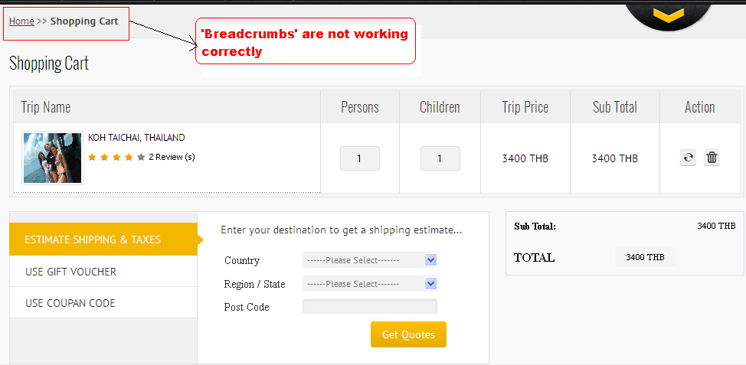

|  |  |  |  |  |  |  |  |  |  |
| --- | --- | --- | --- | --- | --- | --- | --- | --- | --- |
| **Test Case ID** | **Module** | **Features** | **Objectives** | **Step/User Action** | **Expected Result** | **Actual Result** | **Status** | **Developer Comment** | **Tester Comment** |
| TC 23 | My Account | GUI | To verify that the **Checkout** button is mentioned on the page | 1. Enter the URL  **http://192.168.0.26/idive**  2. Click on the **Login** link mentioned on the top right side of the page  3. Enter the valid **Email id** and **Password** and click on the **Login** button  4. Place the mouse over the **Shopping Cart**  5. Now Click on the **View Cart** button  6. Observe the **Checkout** Button on the page | 1. User should be redirected to the Homepage  2. Login page should be appear  3. **Successful Login** message should appear  4. **Shopping Cart** pop up should slide down  5. User should be redirected to the **View Cart** page  6. **Checkout** button should be mentioned on the page | 1. User is redirected to the Homepage  2. Login Page is appearing  3.  **Successful Login** message is appearing  4. **Shopping Cart** pop up is slide down  5. **View Cart** page is appearing  6. Checkout button is not mentioned on the page | Done |  |  |

**Snapshot Attached-**

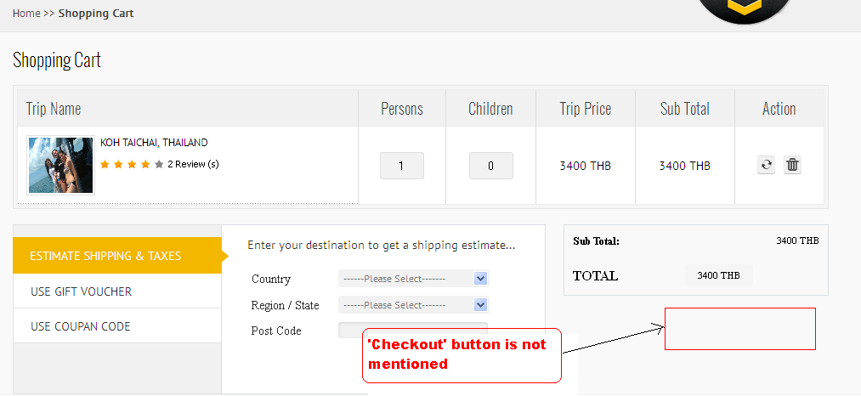

|  |  |  |  |  |  |  |  |  |  |
| --- | --- | --- | --- | --- | --- | --- | --- | --- | --- |
| **Test Case ID** | **Module** | **Features** | **Objectives** | **Step/User Action** | **Expected Result** | **Actual Result** | **Status** | **Developer Comment** | **Tester Comment** |
| TC 24 | My Account | GUI | To verify that the Static texts are spelled correctly | 1. Enter the URL  **http://192.168.0.26/idive**  2. Click on the **Login** link mentioned on the top right side of the page  3. Enter the valid **Email id** and **Password** and click on the **Login** button  4. Place the mouse over the **Shopping Cart**  5. Now Click on the **View Cart** button  6. Read the Static Text mentioned on the page | 1. User should be redirected to the Homepage  2. Login page should be appear  3. **Successful Login** message should appear  4. **Shopping Cart** pop up should slide down  5. User should be redirected to the **View Cart** page  6. Static Text should be spelled correctly | 1. User is redirected to the Homepage  2. Login Page is appearing  3.  **Successful Login** message is appearing  4. **Shopping Cart** pop up is slide down  5. **View Cart** page is appearing  6. Spelling mistake of **“Coupon”** in the menu | Done |  |  |

**Snapshot Attached-**

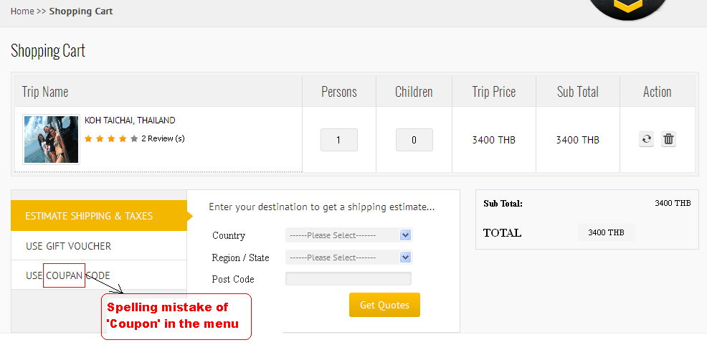

|  |  |  |  |  |  |  |  |  |  |
| --- | --- | --- | --- | --- | --- | --- | --- | --- | --- |
| **Test Case ID** | **Module** | **Features** | **Objectives** | **Step/User Action** | **Expected Result** | **Actual Result** | **Status** | **Developer Comment** | **Tester Comment** |
| TC 25 | Our Trips | GUI | To verify that the Static texts are appearing properly | 1. Enter the URL **http://192.168.0.26/idive**  2. Click on the Header menu **“Our Trips”**  3. Click on the **View Boat Specification** mentioned for the respective Trips  4. Now observe the **Static Texts** mentioned on the page | 1. User should be redirected to the Homepage  2. User should be redirected to the **“Our Trips”** page  3. **Boat Specification** page should be opened  4. **Static Texts** should be mentioned properly on the page | 1. User is redirected to the Homepage  2. User is redirected to the **“Our Trips”** page  3.  **Boat Specification** page is opened  4. **“Digital 2013 Yachts Catalog” & “Digital 2013 international Boats Catalog”** texts are overlapping in the overview tab | Done |  |  |

**Snapshot Attached-**

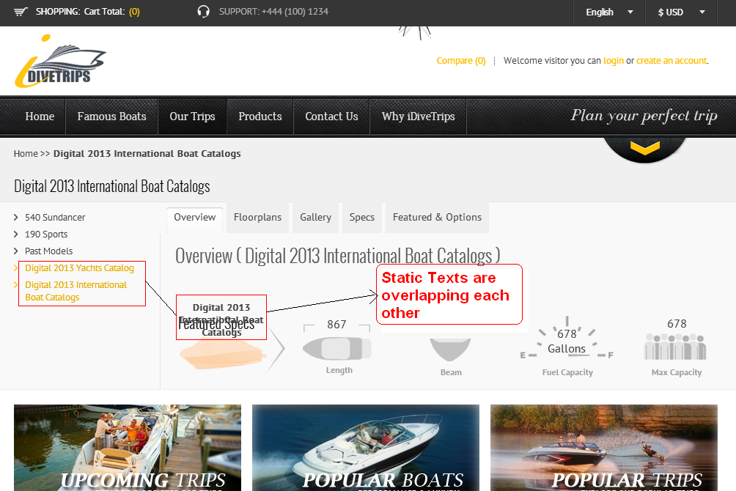

|  |  |  |  |  |  |  |  |  |  |
| --- | --- | --- | --- | --- | --- | --- | --- | --- | --- |
| **Test Case ID** | **Module** | **Features** | **Objectives** | **Step/User Action** | **Expected Result** | **Actual Result** | **Status** | **Developer Comment** | **Tester Comment** |
| TC 26 | Our Trips | Functionality | To validate the functionality of Pagination icon | 1. Enter the URL **http://192.168.0.26/idive**  2. Click on the Header menu **“Our Trips”**  3. Now click on the **Pagination icon** mentioned under the trips | 1. User should be redirected to the Homepage  2. User should be redirected to the **“Our Trips”** page  3.User should be redirected to the next pagination | 1. User is redirected to the Homepage  2. User is redirected to the **“Our Trips”** page  3. Pagination icons are not working | **Done** |  |  |

**Snapshot Attached-**

